## Front End Engineering-II

Project Report

Semester-IV (Batch-2022)

**American Food**

**Supervised By: Submitted By:**

Raveesh Samkaria Shweta Wadhwa

Roll Number: -2210990847

Group - 13

**Department of Computer Science and Engineering**

## Chitkara University Institute of Engineering & Technology,

## Chitkara University, Punjab

**Abstract**

This project encapsulates the development of a frontend website showcasing American cuisine, implemented using HTML and CSS. The website is designed to provide users with an immersive culinary experience, featuring a rich collection of American dishes. Through visually appealing design elements and intuitive navigation, the website aims to engage visitors and evoke a sense of nostalgia for classic American flavors. Emphasizing responsiveness and accessibility, the project underscores the diversity and vibrancy of American culinary traditions while offering users a seamless browsing experience across devices.

窗体顶端

窗体底端

窗体顶端

窗体底端

**Table of Contents**

|  |  |  |
| --- | --- | --- |
| **Sr.no** | **Section** | **Page No** |
| **1.** | Introduction | 4 |
| **2.** | Problem Statement | 5 |
| **3.** | Technical Details | 7 |
| **4.** | File Structure | 8 |
| **5.** | Result | 9 |
| **6.** | References | 28 |

**Introduction**

In today's digital era, the significance of an engaging online presence cannot be overstated, particularly for businesses seeking to connect with their audience effectively. This report encapsulates the journey of crafting a frontend website dedicated to showcasing the vibrant world of American cuisine, utilizing the foundational languages of HTML and CSS. Just as a meticulously prepared dish tantalizes the senses, this website endeavors to captivate users through its visually appealing design and intuitive navigation.

Through the amalgamation of artistic creativity and technical finesse, the website aims to offer visitors an immersive experience, inviting them to explore the diverse flavors and cultural influences that define American food culture. With an emphasis on user engagement and accessibility, each element of the website is meticulously crafted to evoke a sense of culinary curiosity and appreciation. From mouth-watering imagery to interactive features, every aspect of the design aims to transport users on a culinary journey through the heart of America's gastronomic landscape.

This introduction sets the stage for a deeper dive into the development process, where key design choices, technical implementations, and creative solutions will be explored. By documenting the journey from conceptualization to execution, this report not only showcases the fusion of design and technology but also highlights the agency's commitment to delivering exceptional digital experiences. Through the lens of this project, the intersection of culture, cuisine, and digital innovation comes to life, inviting users to savor the essence of American culinary heritage in an immersive online environment.

**Problem Statement**

In the realm of culinary businesses, establishing a captivating online presence is imperative for attracting potential customers and showcasing the unique offerings of the establishment. However, creating an effective front-end website that adequately communicates the restaurant's brand identity, menu offerings, and ambiance while ensuring a seamless user experience presents several challenges.

Firstly, restaurants face the challenge of effectively presenting their diverse menu options in a visually appealing and easily navigable format. Balancing the need for enticing food photography with clear and concise menu descriptions is essential to capture the attention of visitors and encourage them to explore the menu further.

Secondly, designing a responsive website that functions seamlessly across various devices and screen sizes is crucial in today's mobile-concentric world. With an increasing number of consumers using smartphones and tablets to browse the internet, ensuring that the restaurant's website is accessible and user-friendly on all devices is paramount.

Additionally, ensuring accessibility for all users, including those with dietary restrictions or food allergies, is a significant concern for restaurants. Providing detailed information about ingredients, allergens, and dietary options can enhance the dining experience for all customers and demonstrate the restaurant's commitment to exclusivity and customer satisfaction.

In summary, the problem statement revolves around the need to create a front-end website for an American food restaurant that effectively showcases its menu offerings, ensures seamless responsiveness across devices, and provides comprehensive information to cater to the diverse needs of its customers. Addressing these challenges will be crucial in achieving the project's objectives and enhancing the restaurant's online presence and customer engagement.

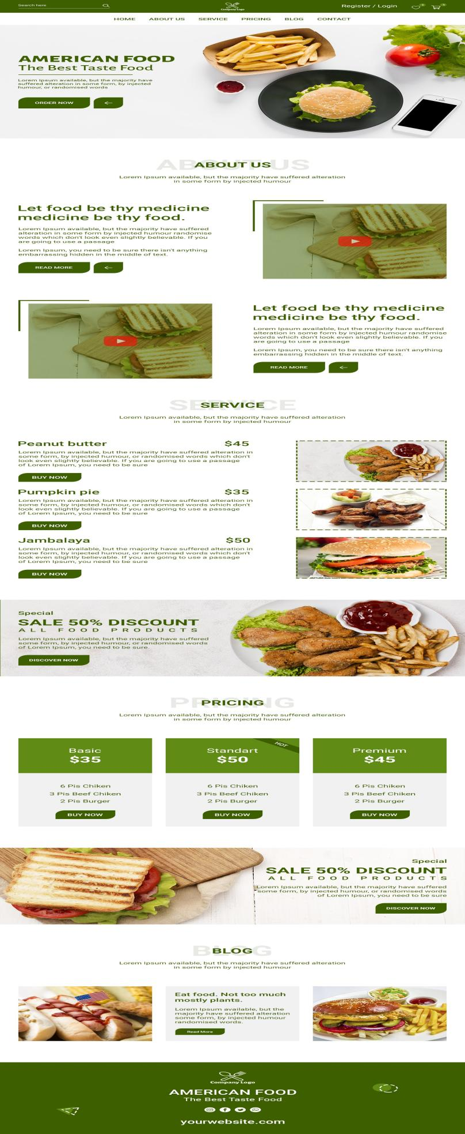

**Technical Details**

The front-end website for the American food restaurant menu was meticulously crafted with a minimalist approach, focusing on essential technologies to deliver a seamless and visually appealing user experience. Here are the key technical details of the project:

1. **HTML Structure:** The foundation of the website was built using semantic HTML markup, enhancing accessibility and clarity for visitors. Each menu page was structured with appropriate tags to facilitate intuitive navigation and readability, ensuring that customers can easily explore the diverse offerings of the restaurant.
2. **CSS Styling:** Cascading Style Sheets (CSS) played a pivotal role in styling the layout, typography, and color schemes of the menu website. Custom CSS rules were meticulously applied to maintain a cohesive visual design throughout the site, while also prioritizing optimized load times and code simplicity to enhance performance.
3. **Responsive Design:** The menu website embraced responsive design principles to ensure seamless compatibility across a variety of devices and screen sizes. Through the strategic use of media queries and flexible layouts, the content and design elements dynamically adapt to different viewing environments, providing an optimal browsing experience for customers whether they're accessing the site on a desktop, tablet, or smartphone.

**File Structure: -**

1. **index.html:** Serving as the central entry point, this HTML file outlines the structure and content of the web pages. It encompasses sections like the header, navigation bar, main content area, footer, and any additional elements necessary for a cohesive user experience.
2. **index.css:** This CSS file houses the styling rules governing the visual presentation of the website. It includes directives on colors, fonts, layout properties, and other stylistic elements, ensuring a consistent and visually appealing design across the site. Both general styling and responsive design considerations are encapsulated within this file.
3. **Assets folder:** Containing a repository of essential resources, the assets folder houses icons, fonts, images, logo images, and social icons utilized throughout the website. Proper organization within this folder ensures efficient accessibility and management of visual assets, contributing to the overall clarity and aesthetic appeal of the site.
4. **Template (13).psd and Template (13).jpg:** These files represent the original design mockup created using Adobe Photoshop. Although not directly integrated into the website's development, they serve as valuable references for design elements, layout, and visual styling, aiding in the consistent implementation of the intended design vision

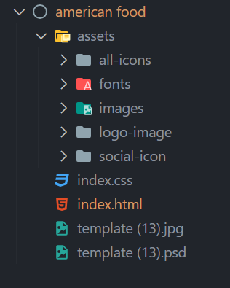

**Result-** Webpage Screenshots: -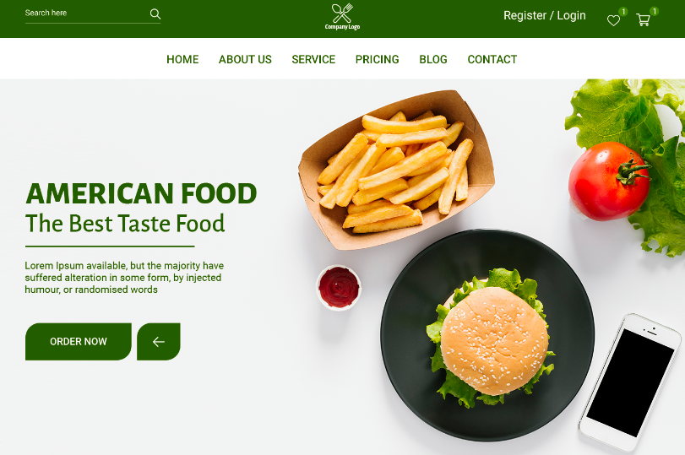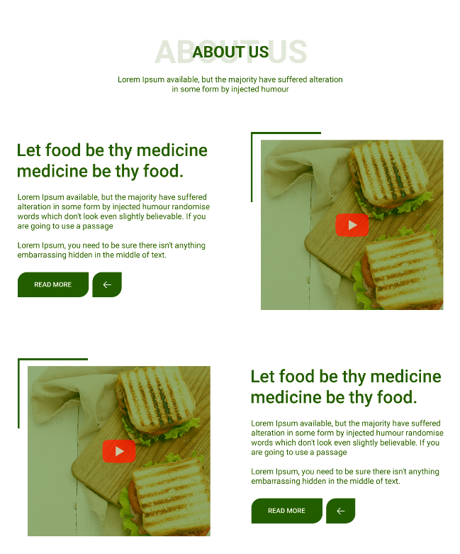

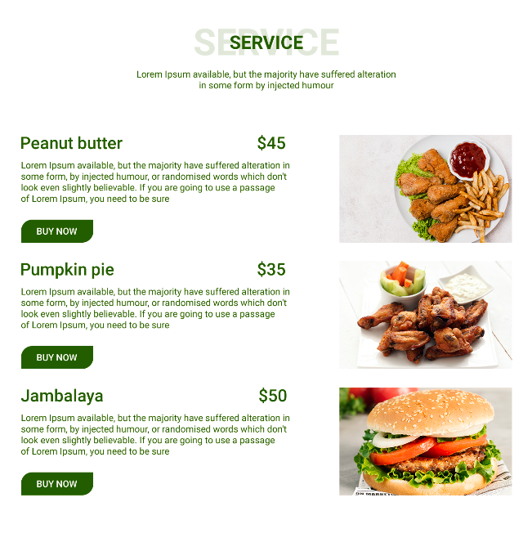

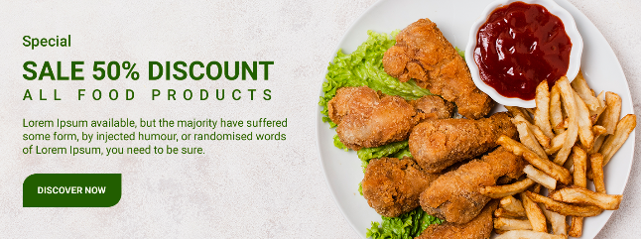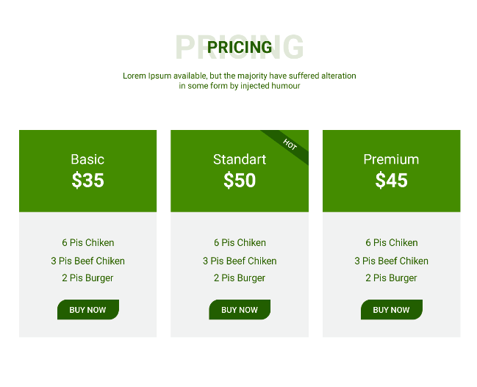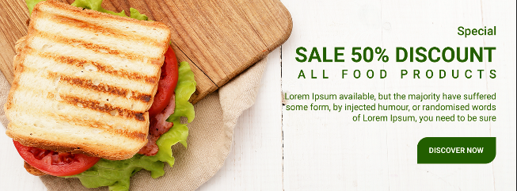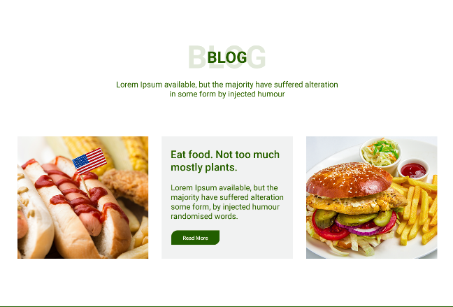

**Code:-**

**Figure 1 Head Tag**

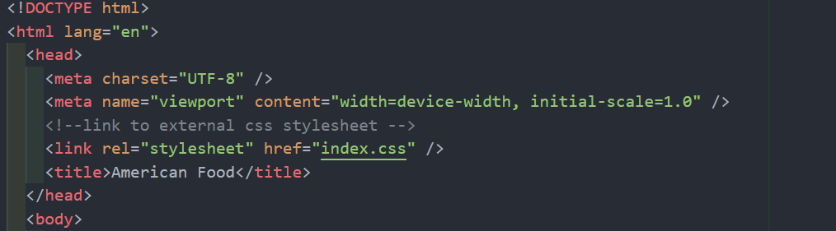

**Figure 2 HTML-mobile section**

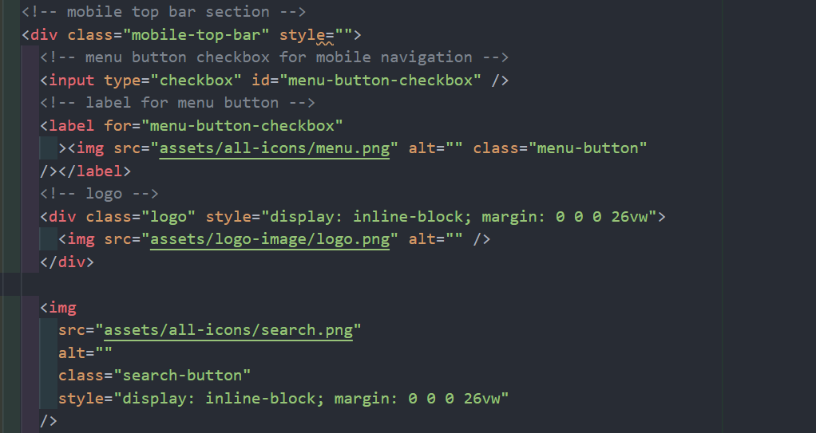

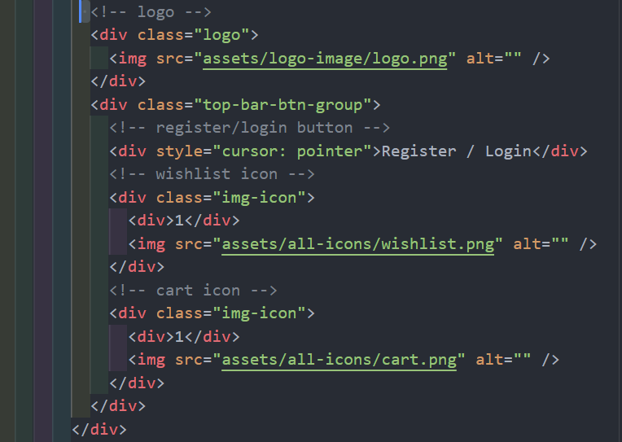

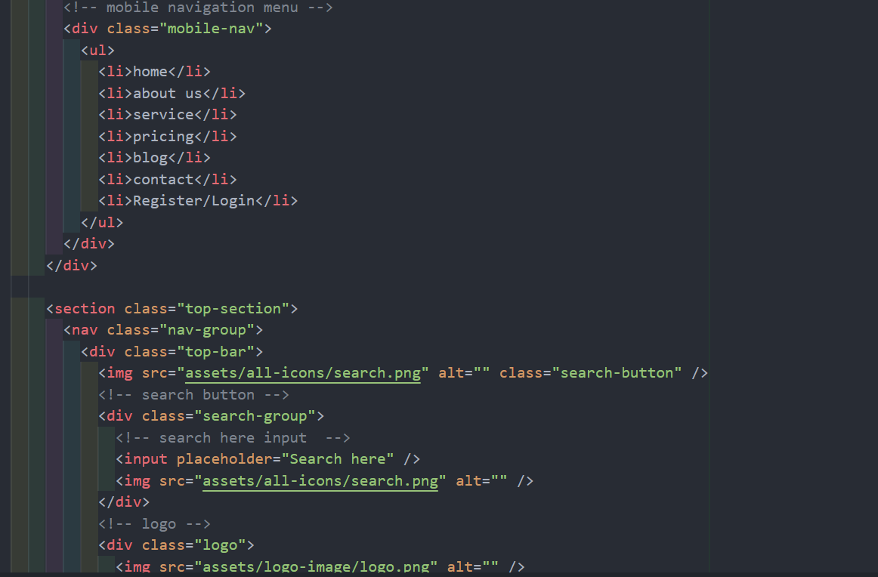

**Figure 5 HTML - Blog Section**

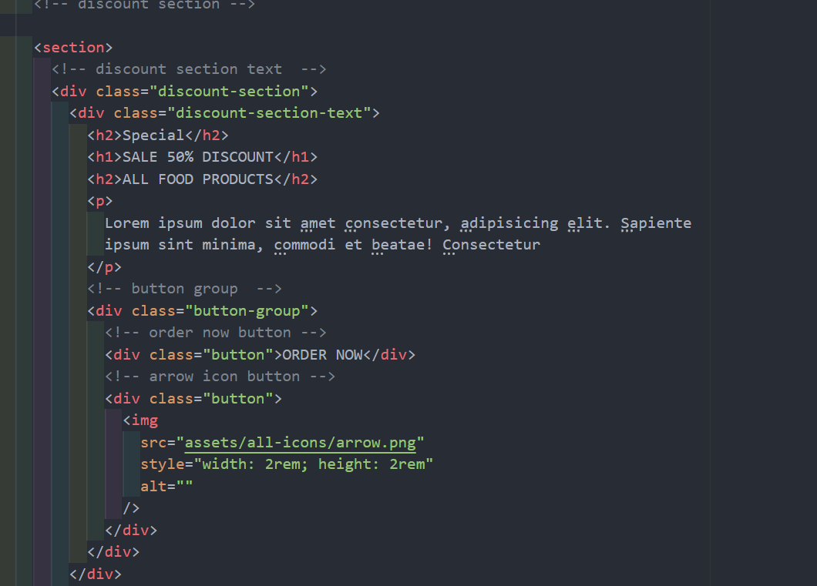

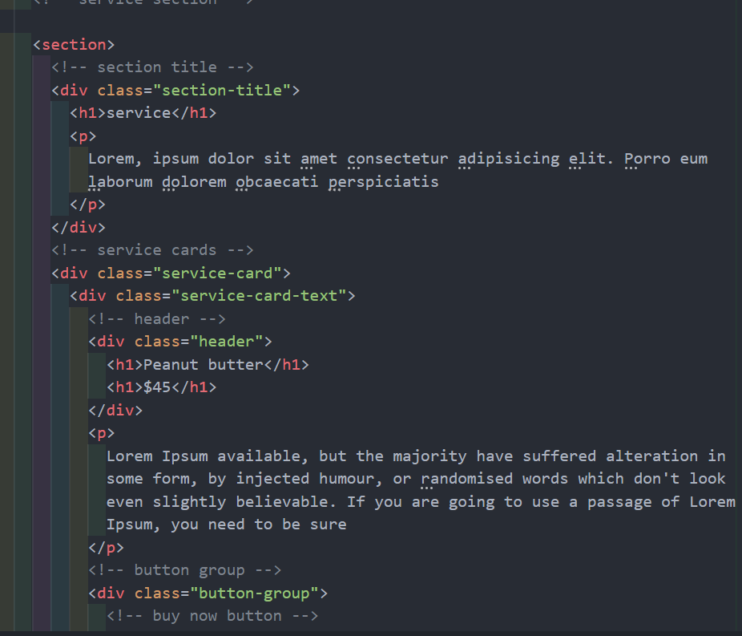

***Figure 7 html - discount section ***

***Figure 8 html - Price card section***

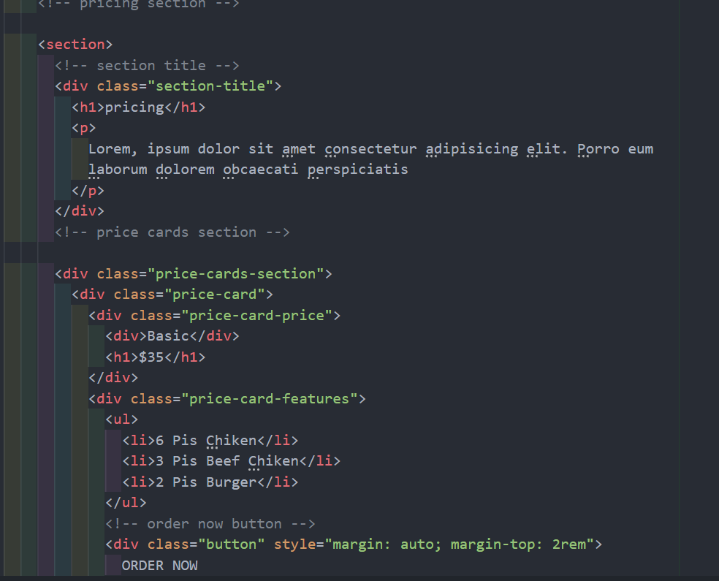

***Figure 9 html - discount section 2***

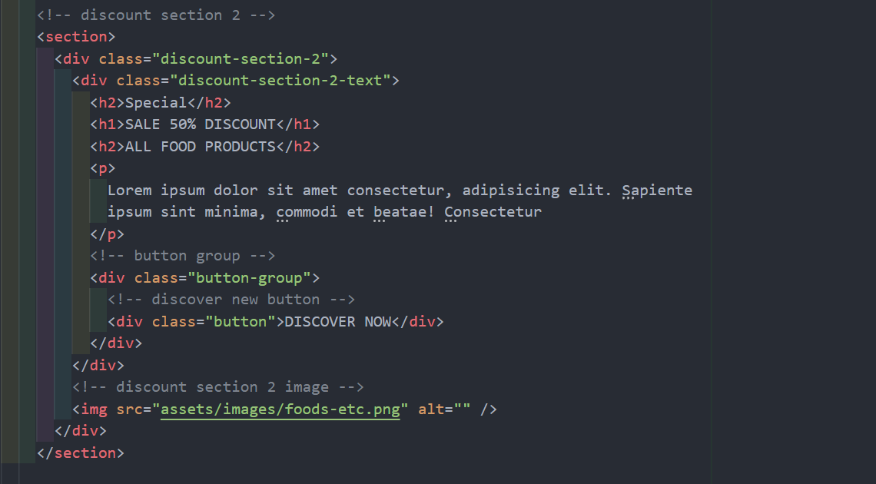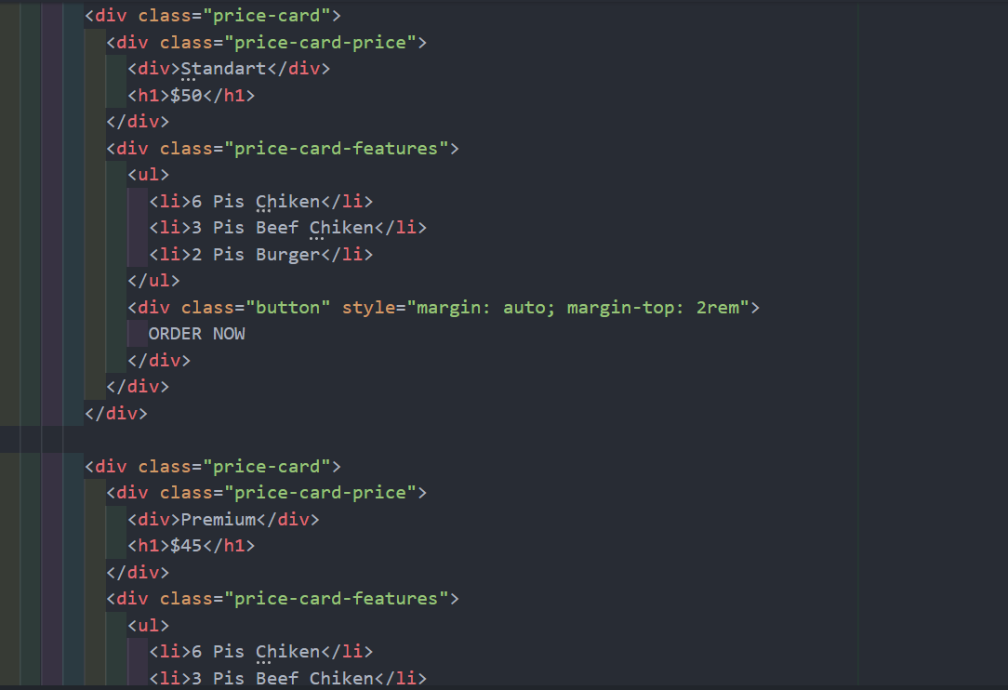

***Figure 10 html - blog section***

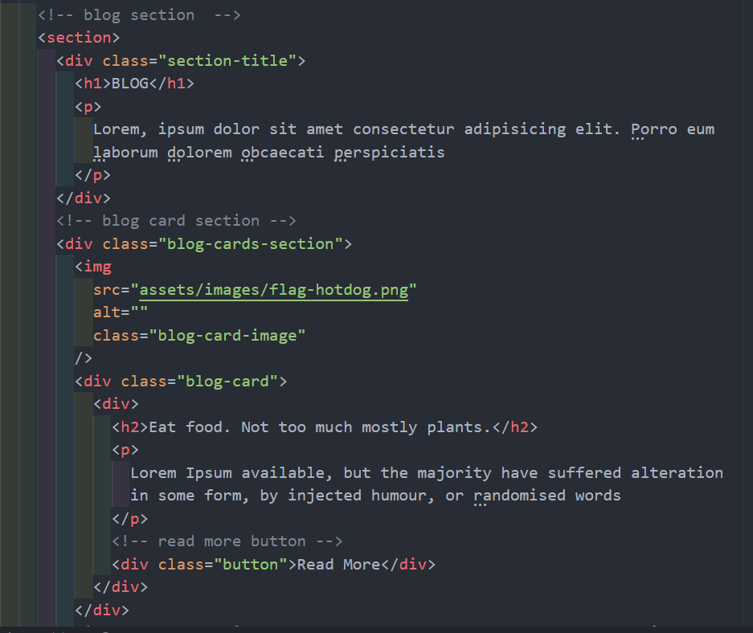

***Figure 11 html - footer section***

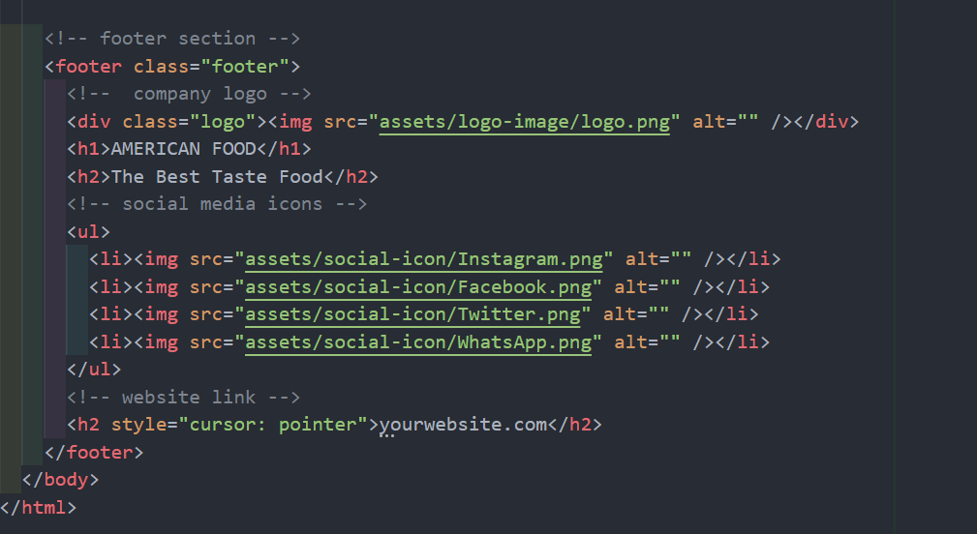

***Figure 12 - css naviagtion bar***

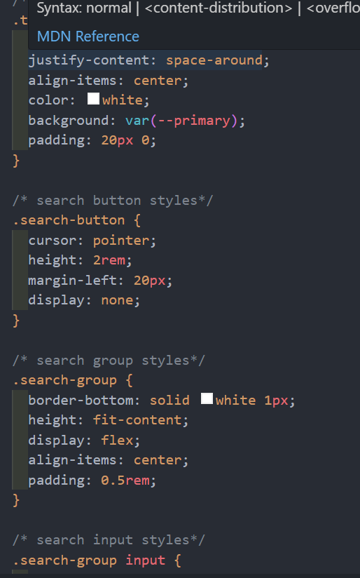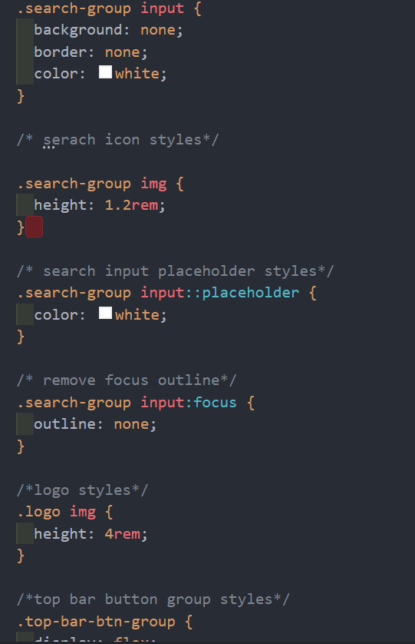

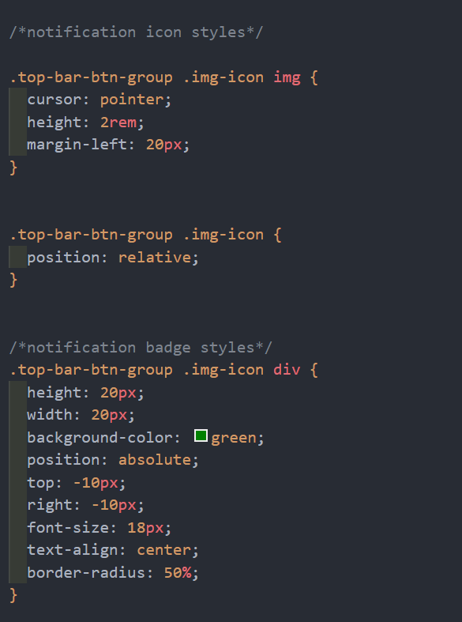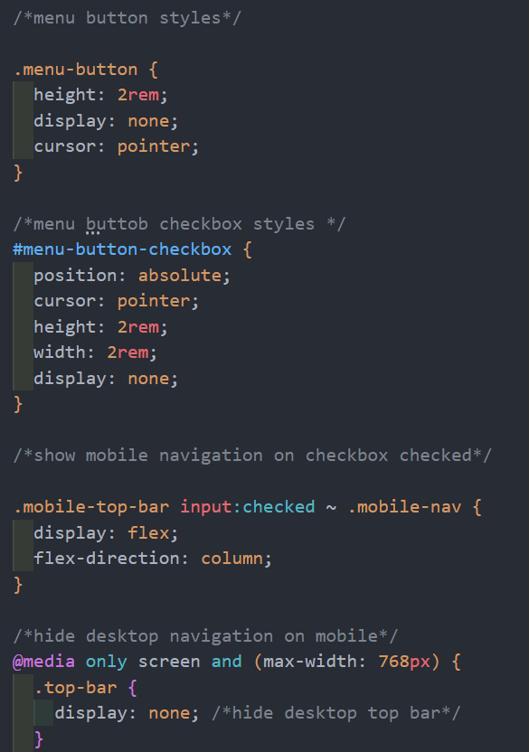

***Figure 13 css-hero section***

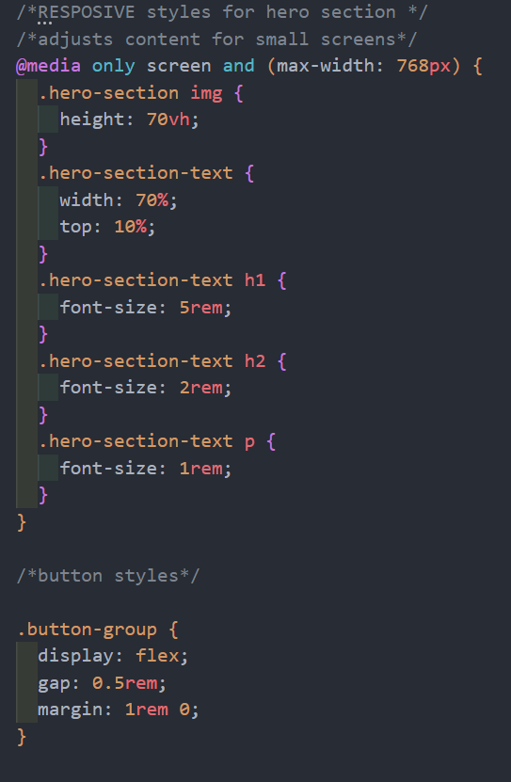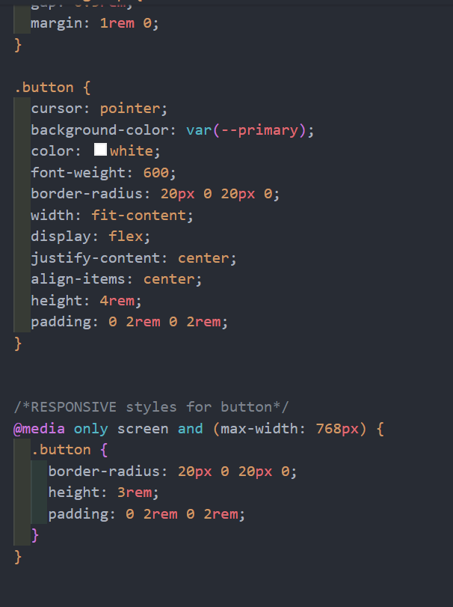

**Figure 15 CSS – discount section**

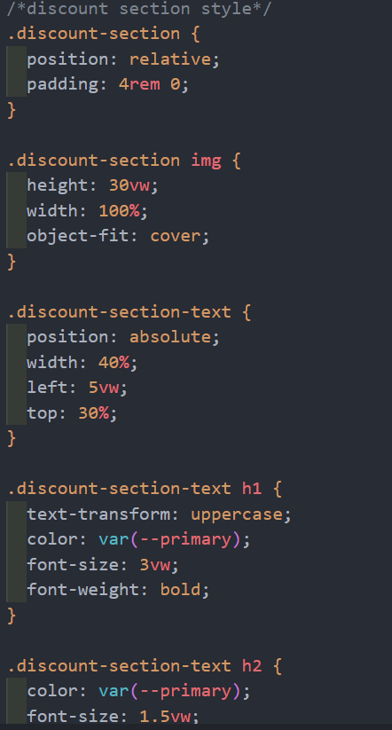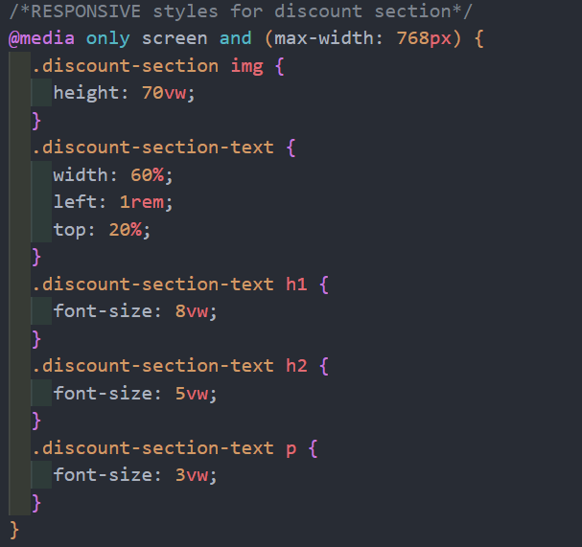

**References**

1. [www.photopea.com](http://www.photopea.com)
2. [www.w3schools.com](http://www.w3schools.com)
3. [www.psdFreebies.com](http://www.psdFreebies.com)
4. <https://fonts.google.com/>